

T DATA Business Solutions

NTT DATA Business Solutions

|  |  |  |
| --- | --- | --- |
| Shahbaz Khan S | SAP ABAP | 24-05-2024 |
| CANDIDATE NAME | POSITION | DATE |

**Section 1- Talent Acquisition**

|  |  |  |
| --- | --- | --- |
| DEPARTMENT, BUSINESS VERTICAL | : | US AMS |
|  |  |  |
|  |  |  |

Experience Summary

|  |  |  |
| --- | --- | --- |
| 1 | Total Experience | 7 |
| 2 | SAP Experience | 7 |
| 3 | Domain experience | 7 |
| 4 | Current Company | Accenture |
| 5 | Education BE ECE | |
| 6 | Certifications |  |
| 6 | How many implementation or support projects |  |
| 8 | Hometown | Chennai |
| 9 | Current location |  |
| 10 | Preferred location |  |
| Any other information : | | |

skills / Knowledge Evaluation

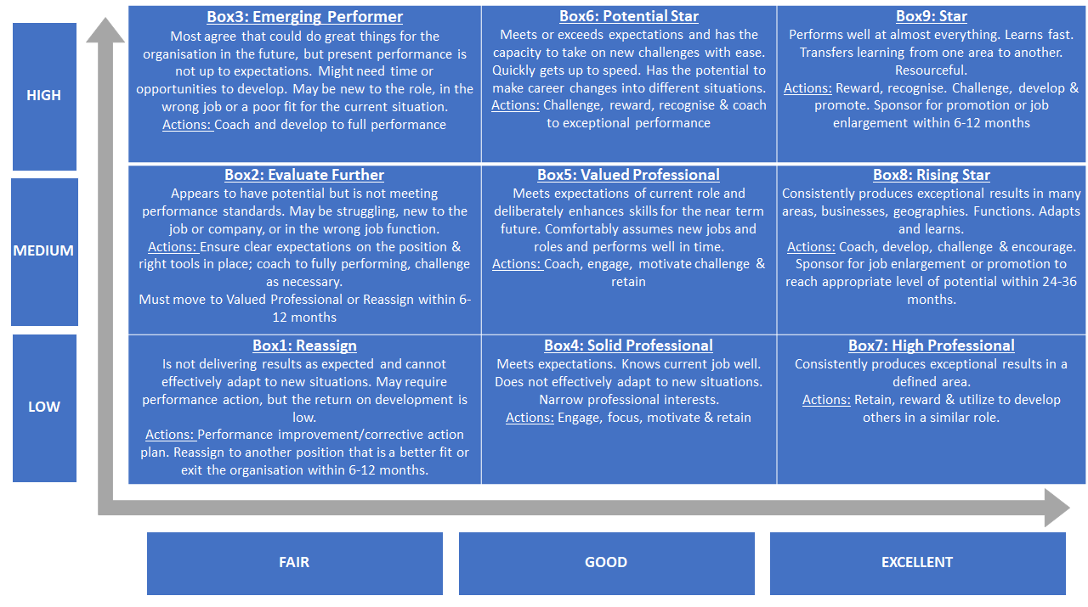

**Potential**

**Performance**

**Section 2 – Technical Discussion**

|  |  |  |
| --- | --- | --- |
| INTERVIEWED BY | : | Click or tap here to enter text. |
| MODE OF INTERVIEW | : | Choose an item. |

**COMMUNICATION**

Tell us about yourself and how do you describe yourself?

|  |  |  |  |  |  |
| --- | --- | --- | --- | --- | --- |
| Rating | 1 | 2 | 3 | 4 | 5 |

Please

|  |
| --- |
| Validate above experience summary: |
| Excellent communications Skills and very Good Experience in S/4 Hana with RAP |

Evaluate the candidate’s skill set:

SAP TECHNICAL SKILLS - Technical Skills

|  |  |  |  |  |  |  |  |  |  |  |  |  |  |
| --- | --- | --- | --- | --- | --- | --- | --- | --- | --- | --- | --- | --- | --- |
| |  |  |  |  |  |  |  | | --- | --- | --- | --- | --- | --- | --- | | |  |  |  |  |  |  | | --- | --- | --- | --- | --- | --- | | Rating Scale | 5 – Exceptional | 4 – Above Average | 3 – Average | 2 – Satisfactory | 1 – Unsatisfactory | | | | | | | | |
|  |  | 1 | 2 | 3 | 4 | 5 |
| SAP ABAP | : |  |  |  |  |  |
| S/4 Hana | : |  |  |  |  |  |
| S/4 Hana RAP | : |  |  |  |  |  |
|  | : |  |  |  |  |  |
|  | : |  |  |  |  |  |
|  | : |  |  |  |  |  |
|  | : |  |  |  |  |  |
|  | : |  |  |  |  |  |
|  | : |  |  |  |  |  |
|  | : |  |  |  |  |  |  |
| OTHER *(Specify Skill)* |  |  |  |  |  |  |

**LEARNING ATTITUDE**

**TECH SAVVY**

What were the recent technologies you have learned and any certifications you have done.

What milestones would you like to achieve in terms of learning?

|  |  |  |  |  |  |
| --- | --- | --- | --- | --- | --- |
| Rating | 1 | 2 | 3 | 4 | 5 |

**BUSINESS KNOWLEDGE**

Can you brief us about the project you worked on earlier, their business/Industry?

|  |  |  |  |  |  |
| --- | --- | --- | --- | --- | --- |
| Rating | 1 | 2 | 3 | 4 | 5 |

|  |
| --- |
| Can we manage / meet his / her expectations from the role? |
| Click or tap here to enter text. |
| Strengths and Weakness: |
| Click or tap here to enter text. |

|  |
| --- |
| ADDITIONAL COMMENTS (ANY RED FLAGS/ THINGS TO REMEMBER) : |
| Shahbaz good experience in S/4 Hana extensive experience in RAP and New Skills and Very Good Experience in CDS views and AMDP |

TRAININGS REQUIRED POST JOINING

|  |  |  |  |
| --- | --- | --- | --- |
| INTERVIEW RECOMMENDATION: | | | |
| Selected | : |  |
| Rejected | : |  |

|  |  |  |  |  |  |
| --- | --- | --- | --- | --- | --- |
| BOX Rating (1 to 9) | | : | 7 | | |
|  | |  |  | | |
|  | |  |  | | |
|  | |  |  | | |
|  | | | | | |
|  |  | | |  |  |

Interviewer Full Name & Signature: Chandra Sekhar Reddy Pagidela

CANDIDATE PHOTO



|  |  |  |
| --- | --- | --- |
| **Section 3 – Fitment Discussion** |  |  |
| |  |  |  | | --- | --- | --- | | INTERVIEWED BY | : | Click or tap here to enter text. | | MODE OF INTERVIEW | : | Choose an item. | |  |  |

**COMMUNICATION**

Tell us about yourself and how do you describe yourself?

|  |  |  |  |  |  |
| --- | --- | --- | --- | --- | --- |
| Rating | 1 | 2 | 3 | 4 | 5 |

**SAP KNOWLEDGE**

Can you brief us about the project you worked on earlier, their business/Industry?

|  |  |  |  |  |  |
| --- | --- | --- | --- | --- | --- |
| Rating | 1 | 2 | 3 | 4 | 5 |

**BUSINESS KNOWLEDGE**

Can you brief us about the project you worked on earlier, their business/Industry.

|  |  |  |  |  |  |
| --- | --- | --- | --- | --- | --- |
| Rating | 1 | 2 | 3 | 4 | 5 |

**OWNERSHIP**

Tell us about a decision you made and failed due to that? How did that impact you

|  |  |  |  |  |  |
| --- | --- | --- | --- | --- | --- |
| Rating | 1 | 2 | 3 | 4 | 5 |

OVERALL INTERVIEW SUMMARY & NOTES:

|  |
| --- |
|  |
| Passion & Attitude:  Click or tap here to enter text.  Is he/ she a team player? |
| Click or tap here to enter text. |
| Is he / she humble? |
| Click or tap here to enter text. |
| Can we manage / meet his / her expectations from the role? |
| Click or tap here to enter text. |
| Strengths and Weakness: |
| Click or tap here to enter text. |
| ADDITIONAL COMMENTS (ANY RED FLAGS/ THINGS TO REMEMBER) : |
| Click or tap here to enter text. |

TRAININGS REQUIRED POST JOINING

|  |  |  |  |
| --- | --- | --- | --- |
| INTERVIEW RECOMMENDATION: | | | |
| Selected | : |  |  |
| Rejected | : |  |
|  | : |  |
|  |  |  |

BOX Rating (1 to 9) :

Interviewer Full Name & Signature: Click or tap here to enter text.

CANDIDATE PHOTO



**Section 4 – HR discussion**

|  |  |  |
| --- | --- | --- |
| INTERVIEWED BY | : | Click or tap here to enter text. |
| MODE OF INTERVIEW | : | Choose an item. |

**(If needs Add HR Questions for example )**

**PLANNING & ORGANISING**

Tell me about a time when you have organized an event, how did you plan?

|  |  |  |  |  |  |
| --- | --- | --- | --- | --- | --- |
| Rating | 1 | 2 | 3 | 4 | 5 |

**ADAPTABILITY**

Tell us about a significant change in your life. How did you handle that?

How do your approach unfamiliar people/ work place/ task?

|  |  |  |  |  |  |
| --- | --- | --- | --- | --- | --- |
| Rating | 1 | 2 | 3 | 4 | 5 |

**CULTURE & VALUE**

Who is your role model? Why?

An unforgettable life experience that has changed your thought process or determined the way of life?

|  |  |  |  |  |  |
| --- | --- | --- | --- | --- | --- |
| Rating | 1 | 2 | 3 | 4 | 5 |

What can you do for us that someone else cannot do?

|  |  |  |  |  |  |
| --- | --- | --- | --- | --- | --- |
| Rating | 1 | 2 | 3 | 4 | 5 |

Interviewer Full Name & Signature: Click or tap here to enter text.

CANDIDATE PHOTO

